# GNU/LINUX Basic commends

1. pwd (Present working directory)

1. date

1. uname, uname -a

(writes to standard output the name of the operating system that you are using)



1. ls (List files and Directory)

5.Directory creation and deletion:

mkdir (make directory)

rmdir (remove directory)

6.Creating sub directory under parent directory

mkdir -p dir1/dir2/dir3

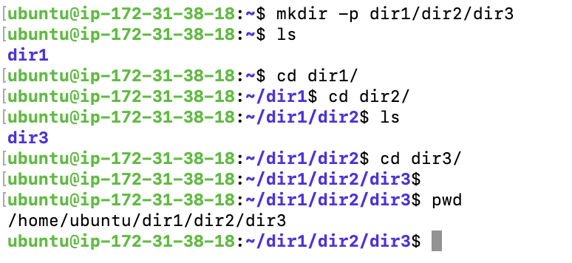

7.Under directory creating text file:

**ubuntu@ip-172-31-38-18**:**~/dir1/dir2/dir3**$ vim test.txt

**ubuntu@ip-172-31-38-18**:**~/dir1/dir2/dir3**$ ls

test.txt

8.Read test.txt file by using cat cmd:

* relative patch

**ubuntu@ip-172-31-38-18**:**~**$ cat dir1/dir2/dir3/test.txt

"hellow world"

* absolute path

**ubuntu@ip-172-31-38-18**:**~**$ cat /home/ubuntu/dir1/dir2/dir3/test.txt

"hellow world"

9.Remove all directory:

Navigate the text file can delete or else we can delete all the folder in single cmd

**10.rm -r removes files from the system**

**ubuntu@ip-172-31-38-18**:**~**$ cat dir1/dir2/dir3/test.txt

"hellow world"

**ubuntu@ip-172-31-38-18**:**~**$ ls

**dir1**

**ubuntu@ip-172-31-38-18**:**~**$ rm -r dir1/

**ubuntu@ip-172-31-38-18**:**~**$ ls

**ubuntu@ip-172-31-38-18**:**~**$

**11.rm -rf removes files from the system forcefully**

**ubuntu@ip-172-31-38-18**:**~**$ rm -rf dir1/dir2/test.txt

**ubuntu@ip-172-31-38-18**:**~**$ ls

**dir1**

**ubuntu@ip-172-31-38-18**:**~**$

**ubuntu@ip-172-31-38-18**:**~**$ ls

**dir1**

**ubuntu@ip-172-31-38-18**:**~**$ rm -rf dir1/

**ubuntu@ip-172-31-38-18**:**~**$ ls

**ubuntu@ip-172-31-38-18**:**~**$

**12.Locate your file or directory:**

**ubuntu@ip-172-31-38-18**:**~**$ locate ssh_config

/etc/ssh/ssh_config

/etc/ssh/ssh_config.d

/snap/core18/2829/etc/ssh/ssh_config

/usr/share/man/man5/ssh_config.5.gz

**13.Creating multiple directory:**

**ubuntu@ip-172-31-38-18**:**~**$ mkdir dir1 dir2 dir3 dir4

**ubuntu@ip-172-31-38-18**:**~**$ ls

**dir1** **dir2** **dir3** **dir4**

**14. deleting multiple directory:**

**ubuntu@ip-172-31-38-18**:**~**$ rmdir dir1 dir2 dir3 dir4

**ubuntu@ip-172-31-38-18**:**~**$ ls

**15.Creating multiple files:**

**ubuntu@ip-172-31-38-18**:**~**$ touch a b c d

**ubuntu@ip-172-31-38-18**:**~**$ ls

a b c d

**16. deleting multiple files:**

**ubuntu@ip-172-31-38-18**:**~**$ rm a b c d

**ubuntu@ip-172-31-38-18**:**~**$ ls

**ubuntu@ip-172-31-38-18**:**~**$

**17. find out text files in directory ( * wildcard )**

**ubuntu@ip-172-31-38-18**:**~**$ pwd

/home/ubuntu

**ubuntu@ip-172-31-38-18**:**~**$ ls

a.txt b.txt c.txt. d.txt **dir1** **dir2** **dir3** **dir4**

**ubuntu@ip-172-31-38-18**:**~**$ ls *.txt

a.txt b.txt d.txt

**18. Delete text files in directory ( * wildcard )**

**ubuntu@ip-172-31-38-18**:**~**$ pwd

/home/ubuntu

**ubuntu@ip-172-31-38-18**:**~**$ ls

a.txt b.txt c.txt. d.txt **dir1** **dir2** **dir3** **dir4**

**ubuntu@ip-172-31-38-18**:**~**$ rm *.txt

**ubuntu@ip-172-31-38-18**:**~**$ ls

c.txt. **dir1** **dir2** **dir3** **dir4**

**19. Determine the total number of lines present in a single file.**

**ubuntu@ip-172-31-38-18**:**/etc**$ cat manpath.config | wc -l

132

**ubuntu@ip-172-31-38-18**:**/etc**$

**20.Shell variables**

**ubuntu@sw-vm-301**:**~**$ env

**21.env variables store**

**ubuntu@sw-vm-301**:**~**$ files="ab.txt,ba.txt"

**ubuntu@sw-vm-301**:**~**$ echo $files

ab.txt,ba.txt

**22.env variables store**

**ubuntu@sw-vm-301**:**~**$ export files

**ubuntu@sw-vm-301**:**~**$ env

**22.env variables remove**

**ubuntu@sw-vm-301**:**~**$ unset files

**22. History commends**

**ubuntu@sw-vm-301**:**~**$ history 10

32 celar

33 clera

34 clear

35 echo $PATH

36 echo $USER

37 echo $HOSTNAME

38 echo $PWD

39 history

40 ls

41 history 10

**23. Bash Profile**

**Vim ~/.bashrc**

**Cd ~/.bashrc**